Title should be written in Times New Roman font size 14 bold type

Topic Area: Please select your topic by clicking here and choosing from T1-T9
Preferred presentation type: Oral presentation ☐ Poster presentation ☐
First Author^{1,*}, Second Author² and Third Author³
*Corresponding Author: email@address.com
^{1.} Affiliation of the first author, including Department/Institution, City and Country.
^{2.} Affiliation of the second author, including Department/Institution, City and Country.
^{3.} Affiliation of the third author, including Department/Institution, City and Country.

Your abstract for ICHEM2020 in Berlin has a very strict one-page limit and should be less than 250 words text. This abstract template has 189 words. The abstract has to be written in English, Times New Roman type with a 12 pt. size. Please do not change the margins, text sizes, or other formatting used in this template. If so, your abstract will be excluded from the proceedings. Presenting author must be stated in italics and identified in bold letters. You may include one figure and references, as long as the limit of one page abstract is not exceeded.
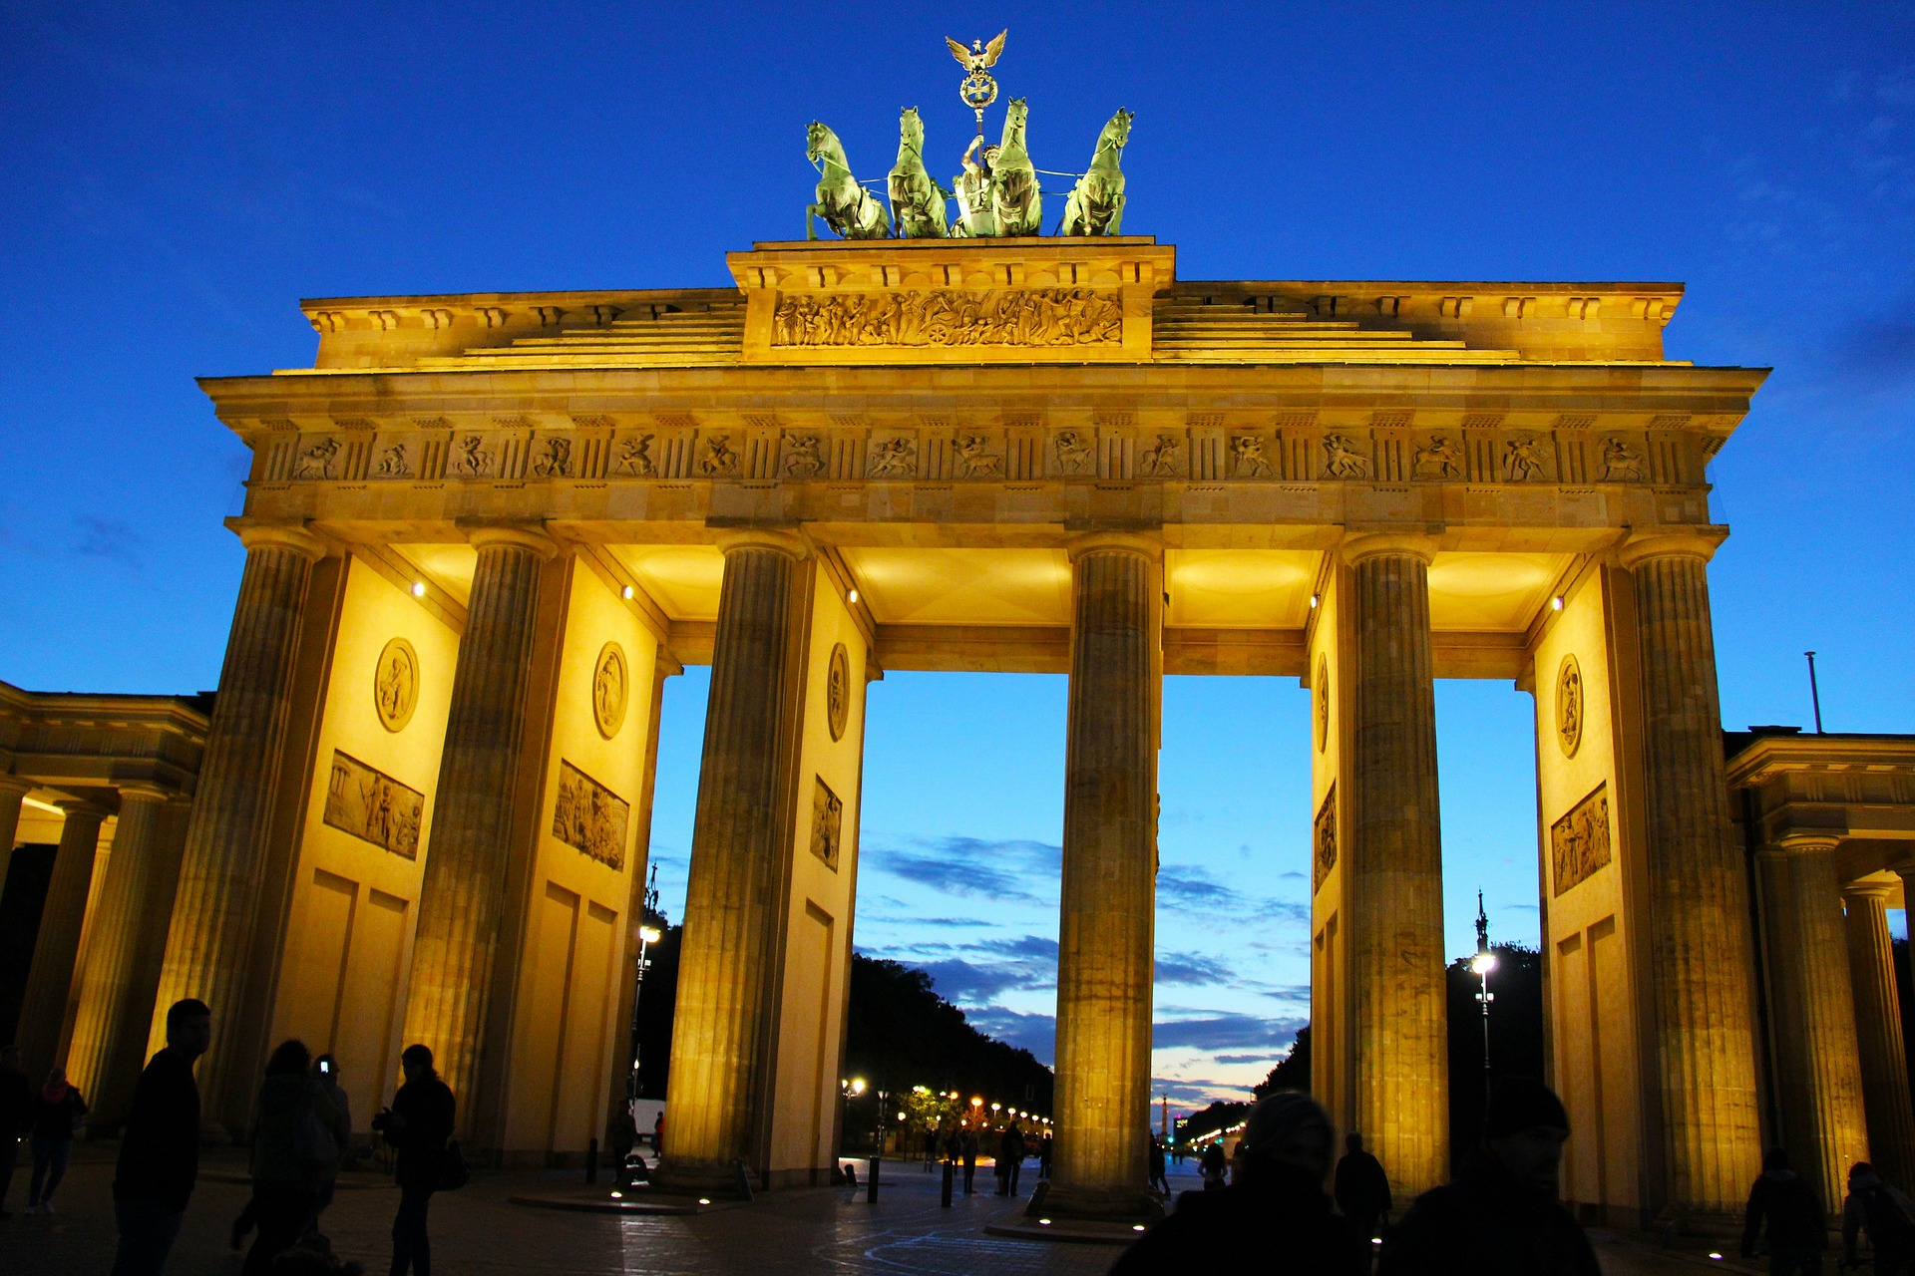
Figure 1: Brandenburg Gate - one of Berlin’s most famous landmarks
Please submit your abstract in Microsoft Word format to sppccahea@uni-bayreuth.de. Please remember to choose a topic area and the type of presentation (oral or poster) at the beginning of this abstract template. You should receive a reply message indicating that your submission is received within a couple of days after submitting. The abstract submission deadline is 12 January 2020. You will be notified of the status of acceptance by 29 February 2020. Early registration ends on 01 May 2020.
Thank you very much for submitting an abstract to ICHEM 2020!

